EBB Firmware : Example logic analyzer traces

These examples generated with v2.9.0 of the EBB firmware.

This command generates 100 steps at 1Khz step rate, with no acceleration, just on motor 1. The move takes 100ms in total.

LM,85899000,100,0,0,0,0,3

Here’s what that looks like on the logic analyzer:

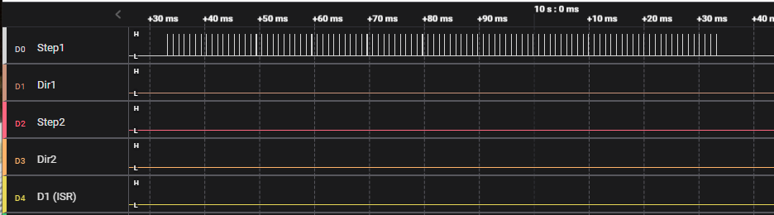

Dir1 stays low, and Step1 gets 1000 pulses, each 1ms apart.

This command generates 100 steps at 1Khz rate but in the other direction for motor 1, and on motor 2 it creates 50 steps at 500hz.

LM,85899000,-100,0,42949500,50,0,3

In the logic trace we see that the Dir1 bit flipped, indicating motion in the other direction, while Dir2 stays low, and we see 100 steps on Step1 and 50 on Step2, both ending after 100ms.

To illustrate the reversal of an axis as its speed goes through zero, consider this command:

LM,85899350,50,-68719,0,0,0,3

It starts out with motor 1 at 1000 steps/s, decelerates to 0 steps/s, then accelerates back up to 1000 steps/s. The move takes 100ms, and there are 25 steps in each direction.

Note that at that zoom level it looks like the direction bit changes simultaneously with a step, but if we zoom in a bit more we can see that the direction bit actually changes at the point where the rate variable goes through zero, regardless of if a step is being taken at that point in time or not.

This next example has both motors reversing direction. We use the LT command to specify a total move time of 1000 ms. Motor 1 starts off at 100 steps/second, decelerates through zero (and changes direction) and then accelerates to 500 steps/second at the end of the move. Motor 2 does the exact opposite, starting at 500 s/s and ending at 100 s/s.

LT,25000,-8589935,-2062,42949675,-2062,0

Here is what this looks like on the logic analyzer:

